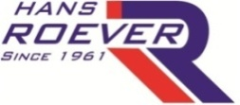 | ROEVER ENGINEERING COLLEGE  (Approved by AICTE, New Delhi. Affiliated to Anna University, Chennai)  Inclusion under Section 2(f) and 12(B) of the UGC act, 1956  ELAMBALUR, PERAMBALUR -621 220 | 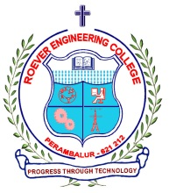

DEPARTMENT OF COMPUTER SCIENCE AND ENGINEERING
REPORT OF FACULTY DEVELOPMENT PROGRAM
Name Of The Event | FACULTY DEVELOPMENT PROGRAM (FDP) |  |  | Date: 07.08.2023
Title : | Chat GPT |  | Conducted Through: | Naan Muthalvan Scheme
Organized By: | Anna University College of Engineering, BIT Campus, Trichy. |  | Duration: | From 24.07.2023 to 28.07.2023
Participant Name: | R.Kannan |  | Designation: | Assistant Professor
Department: | Computer Science and Engineering
Objective : | To understand the fundamental needs & tools of ChatGPT
NAAC Criterion 2 | Teaching Learning and Evaluation
NBA Criterion 5 | Faculty Information and Contributions
Outcomes | At the end of the event, gained the fundamental needs on how to use ChatGPT and know the tools and components used on Chat GPT.
Details of the Trainer | Name & Address | Topic
Details of the Trainer | Mr. Nirmal Kumar  GUVI Learning Solutions | Chat GPT
Description:
The faculty development program was organized well by University College of Engineering, BIT campus Trichy. It is an emerging technology to upgrade the skills and transfer it to students beyond the curriculum. I learned the background concepts in ChatGPT AI tool. The tool helps to solve the real-time problems in all aspect. Additionally I learned the application development methodology through Git-Hub and Visual Studio Code(VSCode)

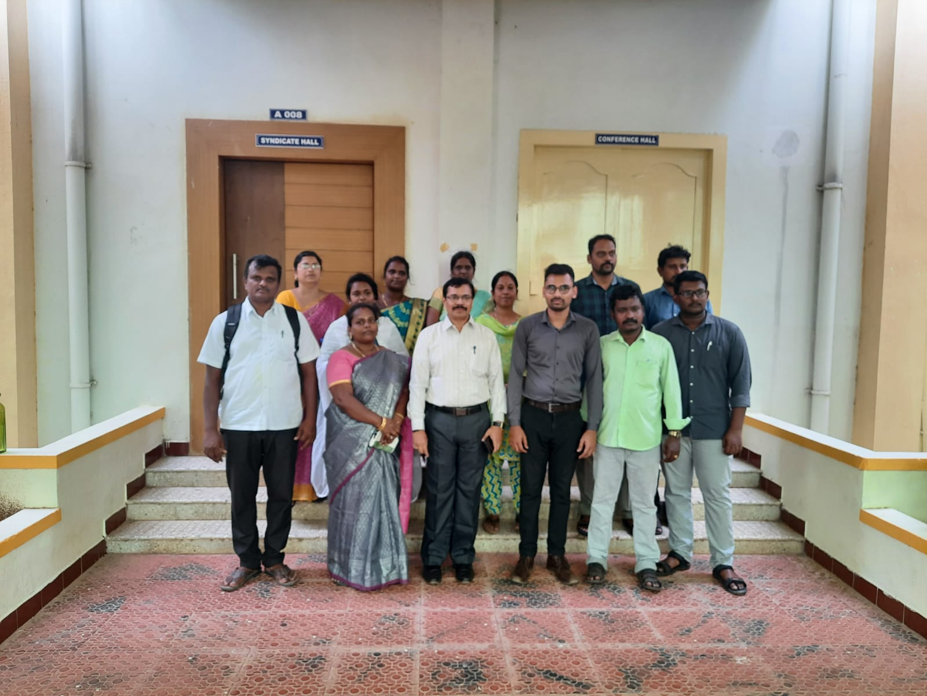

Faculty SPOC HOD /CSE Principal

